Australian Islamic College 2020

ATAR Chemistry Units 3 and 4

Task 10 (Weighting: 5%)

Esters Validation Test

Test Time: 45 minutes

Please do not turn this page until instructed to do so.

First Name | Surname
ANSWERS

Teacher

Mark / 49 | Percentage

Equipment allowed: Pens, pencils, erasers, whiteout, correction tape, rulers and non-programmable calculators permitted by the Schools Curriculum and Standards Authority.

Special conditions:

2 marks will be deducted for failing to write your full name on this test paper.

Teacher help: Your teacher can only help you during your test in one situation.
If you believe there is a mistake in a question show your teacher and your teacher will tell you if there is a mistake in the question and if appropriate, how to fix that mistake.

Spelling of Science words must be correct. Science words with more than one letter wrong (wrong letter and/or wrong place) will be marked wrong.

Equations must be written balanced and with correct state symbols or they will be marked wrong.

Questions must be answered in this booklet.

Total marks: 49

PART ONE: MULTIPLE CHOICE QUESTIONS (4 MARKS)
Circle the correct answer on this page.

- Which of these is not a structural isomer of propyl ethanoate?
  - Butyl methanoate
  - Ethyl propanoate
  - Methyl propanoate
  - Methyl butanoate

- Butyl propanoate will result from the esterification reaction between which pair of molecules?
  - Butane and propanoic acid
  - Butanoic acid and propan-1-ol
  - Propanoic acid and butan-2-ol
  - Propanoic acid and butan-1-ol

- The inorganic substance resulting from the esterification reaction between methanoic acid and ethanol is which of these?
  - Methyl ethanoate
  - Ethyl propanoate
  - Ethyl ethanoate
  - Water

- An esterification reaction between which two substances will produce 1-methylpropylpentanoate?
  - 1-methylpropanol and pentanoic acid
  - Propan-1-ol and pentanoic acid
  - Pentan-1-ol and propanoic acid
  - Butan-2-ol and pentanoic acid

END OF MULTIPLE CHOICE SECTION

PART TWO: SHORT ANSWER QUESTIONS (45 marks)

- Draw the full structure, including all bonds and all hydrogen atoms, and name, the ester with the lowest relative molecular mass.
[2 marks]
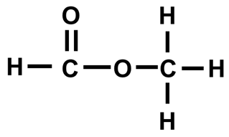
Full structure with no mistakes (1)
Methyl methanoate (1)

- Draw a full structural diagram of ethyl ethanoate, including all bonds and all atoms. Include in your diagram all lone pair electrons.
[2 marks]

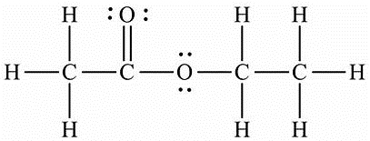
Full structure with no mistakes, other than lone pair electrons (1)
All lone pairs drawn in correctly, in correct location (1)

- Esters have highly electronegative oxygen atoms. They also have hydrogen atoms. Despite this, hydrogen bonding does not occur between ester molecules. Explain why not.
[1 mark]

For hydrogen bonding to occur there must be hydrogen atoms covalently bonded to highly electronegative atoms (which there are not in esters) (1).

- Despite not being able to hydrogen bond to each other, esters can hydrogen bond with water. Draw a diagram to show hydrogen bonding between water and the carbonyl oxygen in methyl ethanoate. Use a dashed line to indicate the hydrogen bond. Use “delta plus” and “delta minus” symbols to indicate the partial positive and negative charges on the atoms involved in forming the hydrogen bond.
[3 marks]
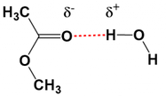

Structures of methyl ethanoate and water (condensed structure OK) (1).
Hydrogen bond (1).
Delta + and Delta minus symbols both correct (1).

- Below is information about four substances. You may assume that there is no significant difference between the relative molecular masses of the substances.

Condensed Structural Formula | IUPAC Name | Relative Molecular Mass | Boiling Point (ºC)
CHO₂CH₃ | Methyl methanoate | 60 | 32
CH₃CH₂CH₂CH₃ | Butane | 58 | -1
CH₃CH₂CH₂OH | Propan-1-ol | 60 | 97
CH₃COOH | Ethanoic acid | 60 | 118

The boiling points of the four substances in random order at -1 ºC, 32 ºC, 97 ºC and 118 ºC.
  - Complete the second column by naming the molecules shown in the first column.
[2 marks; ½ each]

  - Complete the last column of the table by inserting the boiling points corresponding to each substance.
[3 marks maximum; Number of marks = number correct subtract one]

  - List in order of decreasing strength ALL the intermolecular forces present between molecules of these substances.
    - CH₃COOH
[1 mark; no half marks]
Hydrogen bonding, dipole-dipole forces and dispersion forces (in that order).

    - CHO₂CH₃
[1 mark; no half marks]
Dipole-dipole forces and dispersion forces (in that order).

  - Explain the difference between the boiling points of CH₃CH₂CH₂CH₃ and CHO₂CH₃ by referring to specific structures in each molecule and the resulting intermolecular forces.
[8 marks]

The strongest / only intermolecular force in CH₃CH₂CH₂CH₃ / butane is dispersion forces (1)
Which result from the presence of electrons / the asymmetrical distribution of electrons (1)
Whereas in CHO₂CH₃ / methyl methanoate there are both dispersion forces (1) and dipole-dipole forces (1)
These dipole-dipole forces result from the presence of two (1) carbon-oxygen bonds (1) which are polar bonds / make CHO₂CH₃ a polar molecule/substance (1).
The energy required to separate molecules of CHO₂CH₃ / methyl methanoate is greater than the energy required to separate molecules of CH₃CH₂CH₂CH₃ / butane (1).
The boiling point of CHO₂CH₃ / methyl methanoate is greater than the boiling point of CH₃CH₂CH₂CH₃ / butane (1).
Any 8 points.

- The following questions refer to the video ‘Making Esters’.
  - What was the catalyst?
[1 mark]
(Concentrated) sulfuric acid / H₂SO₄.

  - How did the catalyst increase reaction rate?
[2 marks]
It provided an alternative reaction pathway (1)
With a lower activation energy (1).
Alternatively (cannot award one point from each)
By heating the reaction mixture (1) which increases the number of collisions / increases the number of successful collisions (1)

  - Esters were described as ‘volatile’. Suggest why they are more volatile than water by referring to specific structures within these molecules.
[5 marks]
Hydrogen bonds form between water molecules (1)
Due to the presence of hydrogen atoms bonded to (highly electronegative) oxygen atoms (1)
The strongest intermolecular force between ester molecules are dipole-dipole forces (1)
Due to the carbon-oxygen bonds (1)
Hydrogen bonds are stronger intermolecular forces than dipole-dipole forces (1).

  - Name and explain the purpose of the method used to smell the esters that were made in this video.
[3 marks]
Wafting / Waft (1).
Many organic compounds give off poisonous fumes / the esters / alcohols are toxic (1)
And smelling them directly is dangerous / this method avoids smelling them directly (1).

  - Name a safety hazard in ester production and a safety precaution against that hazard.
[2 marks]
Many possible correct answers, at the teacher’s discretion.
e.g. Sulfuric acid is corrosive / Wear a lab coat or wear gloves or wear safety glasses.
Mark for safety precaution must relate to named safety hazard.

  - State observations for the synthesis of ethyl ethanoate.
[4 marks]
A colourless liquid is added to a colourless liquid (1) with a vinegar-like odour (1). The reaction mixture becomes hot (1).
The vinegar-like odour disappears (1).
The liquid remains colourless (1).
An unpleasant odour / the odour of paint thinners appears (1).
A separate layer forms on top (of the sodium carbonate solution) (1).
- Shown below are the two molecules shown being made in the video. These are labelled below are molecules A and B.

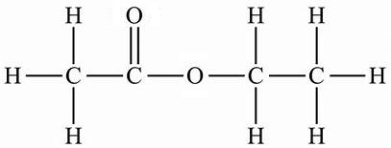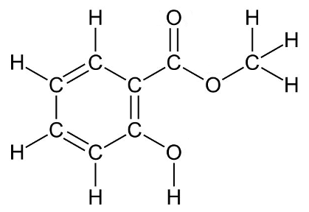

A B

State which molecule, A or B, will be more soluble in water. Explain why.
[5 marks]

A will be more soluble in water than B (1 – this point is not awarded without at least one point being awarded for the explanation).
Stronger dispersion forces will exist between molecules of B than A (1).
Because of the benzene ring / larger non-polar / hydrocarbon structure / greater molar mass / greater relative molecular mass (1).
Also hydrogen bonds exist between molecules of B (but not A) (1).
During dissolution in water energy is required to separate solute molecules (1)
More energy is required to separate molecules of substance B (than A) (because of the stronger dispersion forces and hydrogen bonds) / The intermolecular forces are greater between molecules of B than A (1).

Blank Page For Student Use. This Page Will Not Be Marked.

